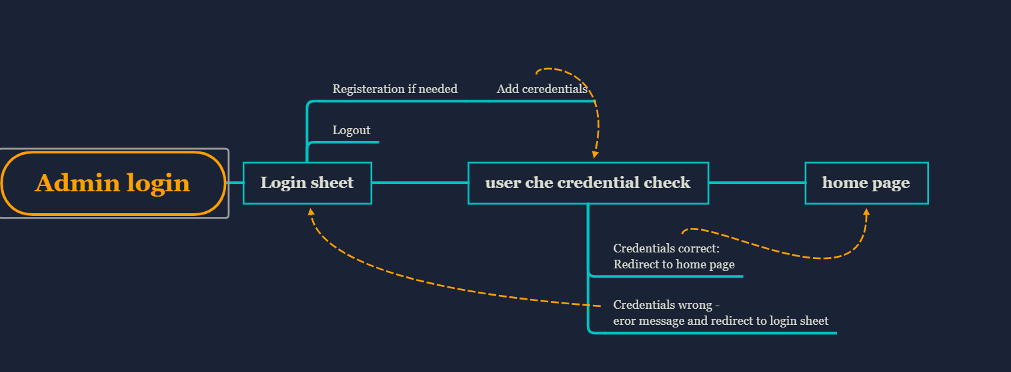

**Admin Login Flow of Controller**